AM000-Asia-China-Warring States-Five T-Bronze-475-221 BCE

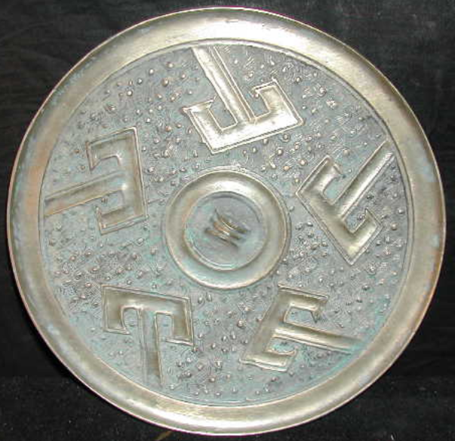

Hunan, Ch'ang-te and the Huai valley

References: Bernard Karlgren, Some Pre-Han Mirrors, BMFEA 35(1963): 161-169 plus plates, p. 164 and pl. 4c- the shan characters point upward instead of downward;

Robert W. Swallow, Ancient Chinese bronze mirrors. Rev. and enlarged ed. by Fred Belcher. Ann Arbor: Ars Ceramica, Ltd., 1977, Fig. 17, the shan characters point downward but there are 2 petals separating each shan figure from the next.

Five is an auspicious number from earliest times in Chinese symbolism signifying the five mountain ranges forming the southern boundary of the empire at the accession of the Ch'in dynasty (221 - 206 BCE). If these five shan characters indicate these mountain ranges the dating of this mirror would be close to 221 BCE since the shan design is definitely an earlier Warring States convention.

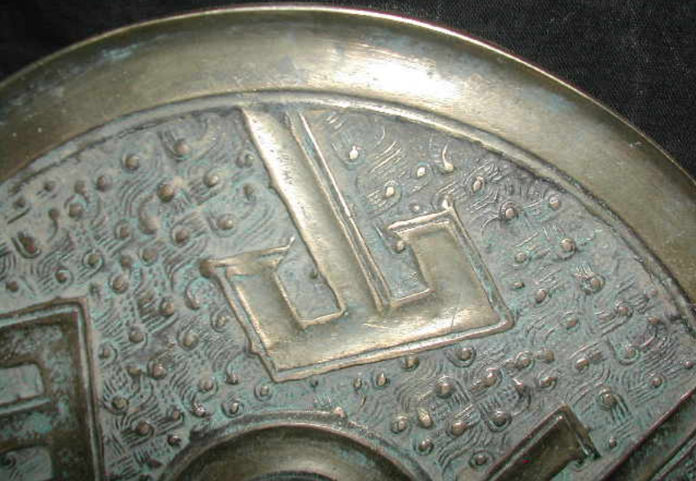

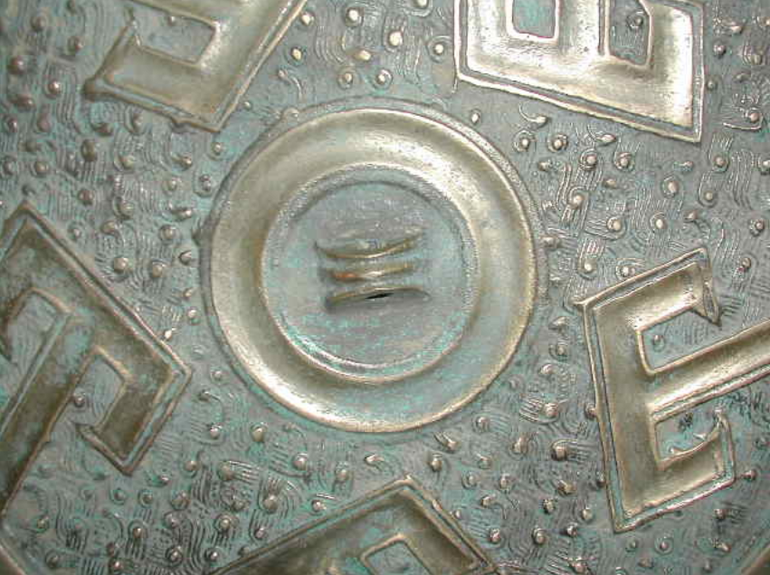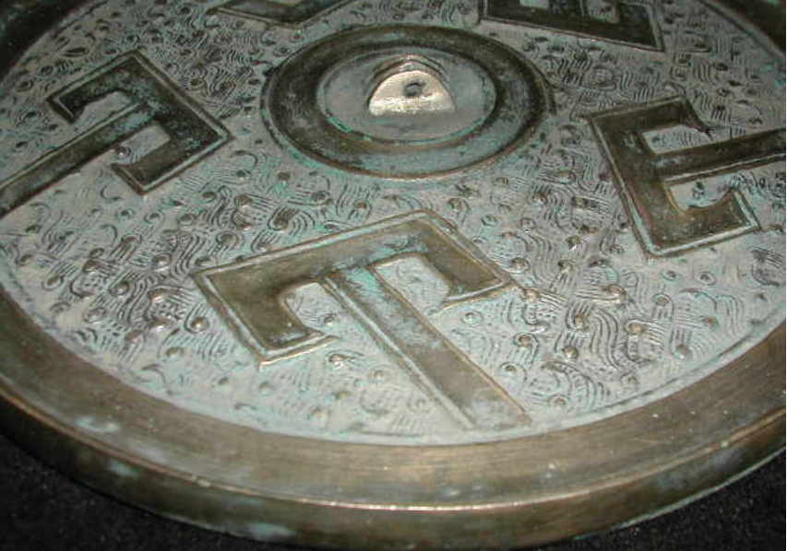

length: 19.50cm  
Width: 19.50cm   
Thickness:1.0cm  
Weight: 1.1 kg